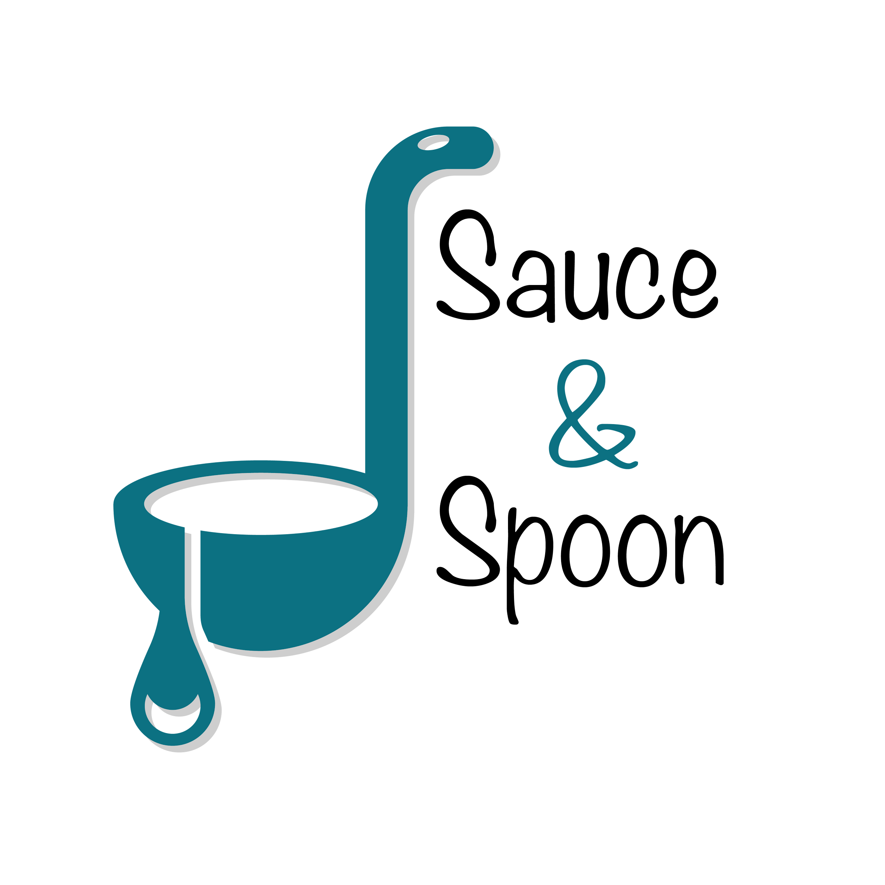
Project Charter: Pilot Rollout of Tabletop Menu Tablets at Sauce & Spoon North and Downtown locations

DATE: [06/4/25]
PREPARATION DATE: Q1 February 2025 - March 2025
PILOT START DATE: Q2 April 2025 - June 2025

Project Summary
Sauce & Spoon will launch a pilot rollout of tabletop menu tablets at the bar area of two restaurant locations, Sauce & Spoon North and Sauce & Spoon Downtown. Using tabletop menu tables, guests can place their orders on the tablets as soon as they arrive at the restaurant, rather than waiting for a server to attend to them.

Project Goals
- Increase appetizer sales by 15% by the end of June 2024 by upselling appetizers and promoting certain entrees
- Increase average check value by $10 by the end of Q2 by selling more appetizers and specialty beverages
- Increase the average daily guest counts by 10% by the end of June 2024 by reducing the average table turn time by about 30 minutes through the use of menu tablets
- 100% working tablets with the existing POS system and host software by the end of Q2
- Decrease employee burnout and turnover by 10% by the end of June 2024 by improving the satisfaction of the kitchen staff
- Cut food waste by 25% by the end of Q2 by TBD

Deliverables
- Tablet package that has menu item add-on feature for appetizers and specialty drinks and coupons
- Increase average check value from $65 across to at least $75
- 50 minutes average table turn time in the bar area
- Have a record of when the guest modifies a menu item
- Training of the staff on the new system
- Tablet software compatible with the existing systems
- Tablets installed in the bar area of North and Downtown locations

Scope and Exclusion
In-Scope:
- Sauce & Spoon North and Sauce & Spoon Downtown Bar Area

Out-of-Scope:
- Policy on order returns

Benefits & Costs
Benefits:
- Speed up the process
- Increase sales
- Decrease turnover rate
Costs:
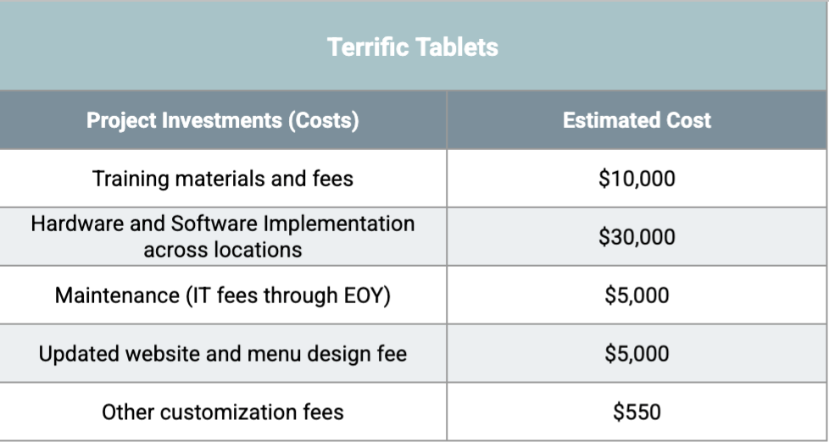

Appendix:
- Agreed to reach the goal of 15% average increase in appetizers sales, with the North location targeted for a 10% increase and the Downtown location targeted for a 20% increase. That way, the goals stay relevant to the unique trends of each location while still supporting the larger company goal. (Email: Sales Goal Details Peta, Alex & Gilly)
- Pending: Deanna’s confirmation about the removal of guest wait time goal (Video Chat: Decrease Guest Wait Time Peta, Alex & Gilly)
- Pending: Hiring more staffs like line cooks, bussers and runners. (Video Chat: Decrease Guest Wait Time Peta, Alex & Gilly)
- Agreed to have a pilot implementation on April and measuring the results through the end of June (Video Chat: Decrease Guest Wait Time Peta, Alex & Gilly)
- Agreed to be out of scope: Adjusting our policy on order returns due to error as part of the tablet rollout. Now we won’t have to replace meals when a guest claims we got their order wrong because the tablet will show that we didn’t. (Meeting: Scope Details w/ Deanna, Carter, Gilly, Alex & Peta)
- Pending: Improvement of the satisfaction of the kitchen staff needs specific metrics(Meeting: Scope Details w/ Deanna, Carter, Gilly, Alex & Peta)

